SQL Interview Questions

***What is SQL?

* SQL (Structured Query Language) is a standardized programming language used for managing and manipulating data in relational database management systems (RDBMS).

1. Query to create Data Base and Table.

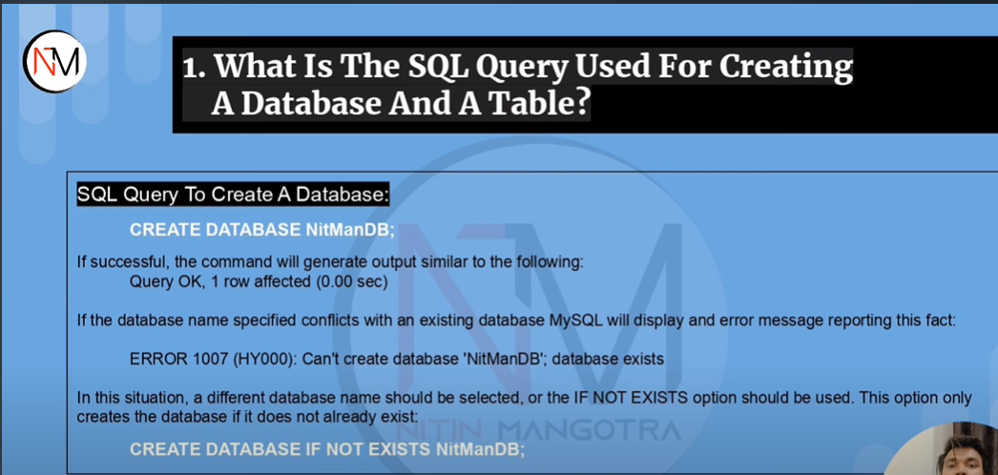

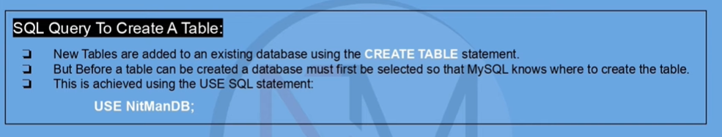

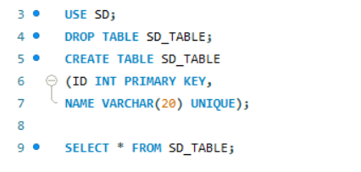

1. SQL query to create a table with the same structure (only structure) of another table.

* Here we must use a False statement so that the structure only gets copied not the data.

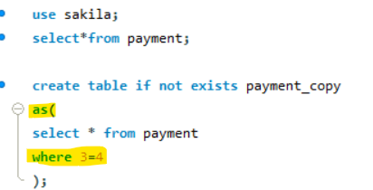

1. Write a Query to create a duplicate table having same structure and data as another table.

* Here we do not need to use the false statement as we want to copy the data along with the table’s structure.



1. SQL query to find ‘n’th highest salary (‘n’th highest value of any particular column—mostly asked 2nd or 3rd highest element).

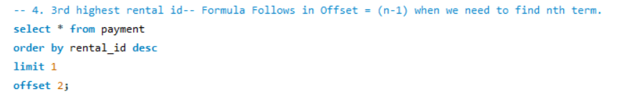

5. Write SQL query to find out the employees who also hold the Managerial Position.

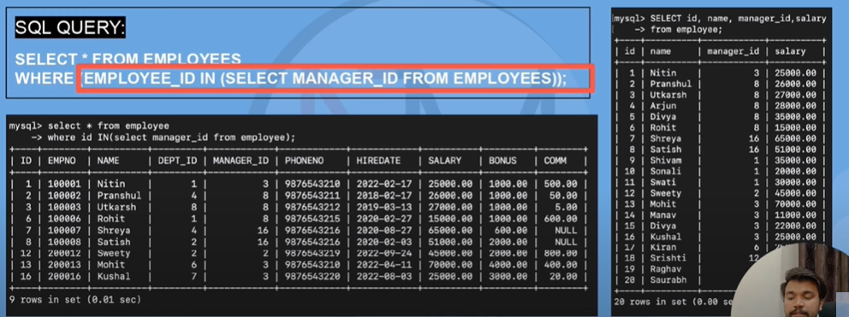

6.Write a SQL query to find out the actor names starting with letter ‘a’.

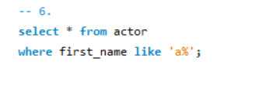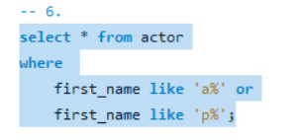

7. SQL query to find current date.

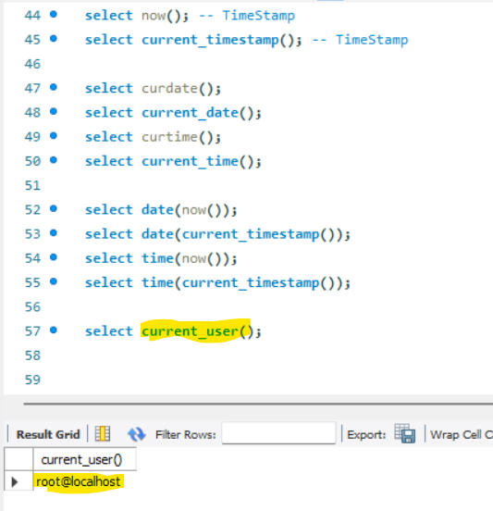

8. a. SQL query to fetch alternate record from a table.

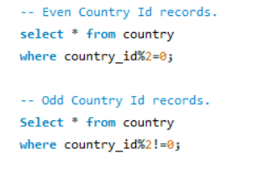

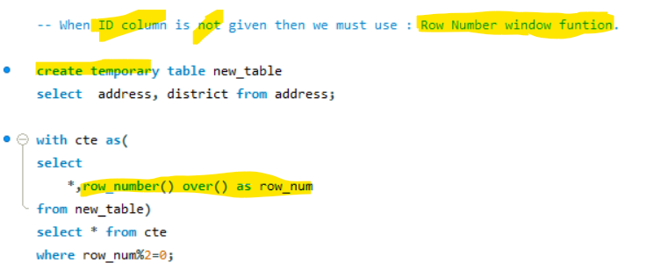

8.b. SQL query to fetch the common records between two tables.

* We simply need to use “Inner Join”.

9. a. SQL query to find duplicate rows in a table.

* Here we need to use Group By for a particular column where we are searching for duplicate elements and need select the rows where the count is greater than one. Here we need to use Having.

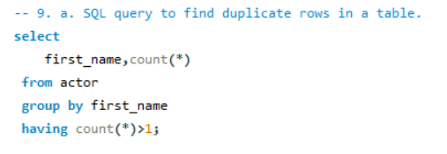

9. b. **Important**.

How to remove duplicate rows from a table in SQL.

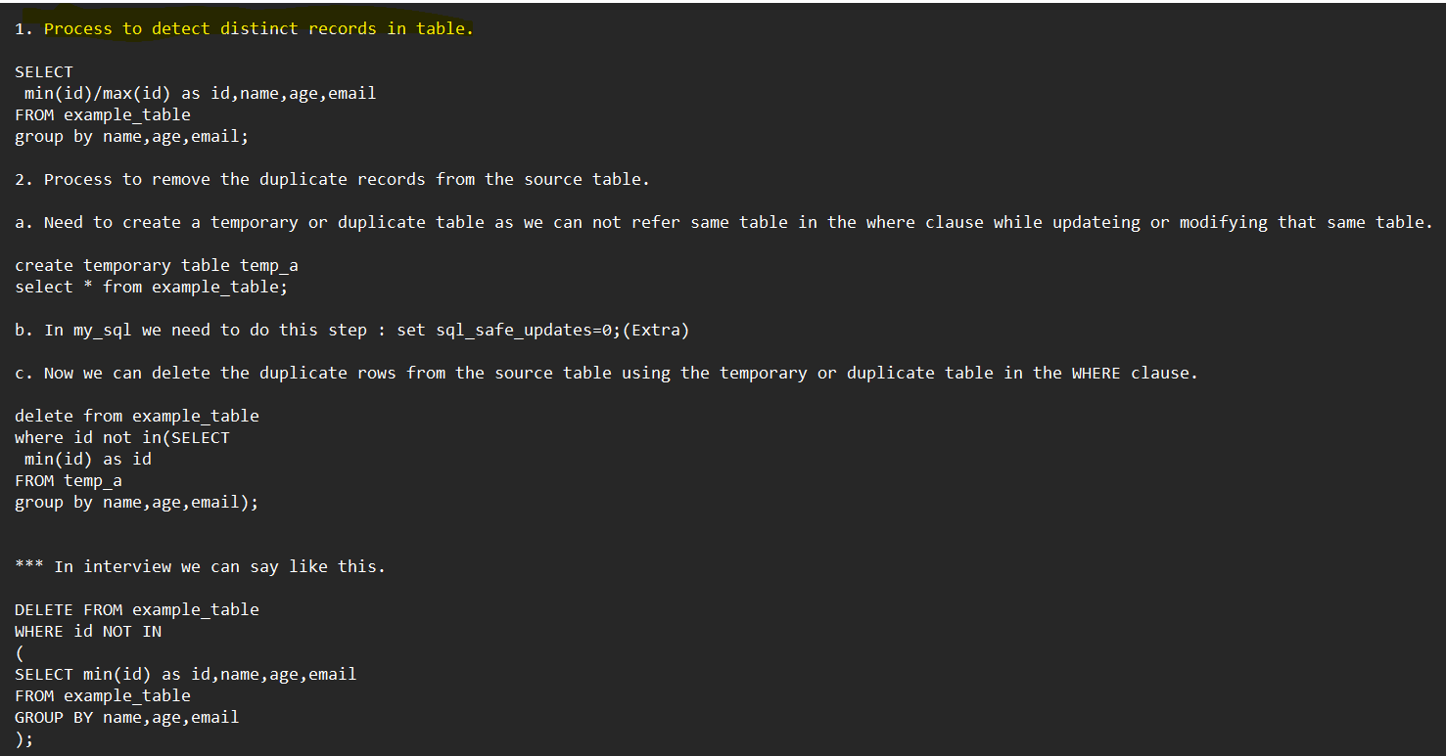

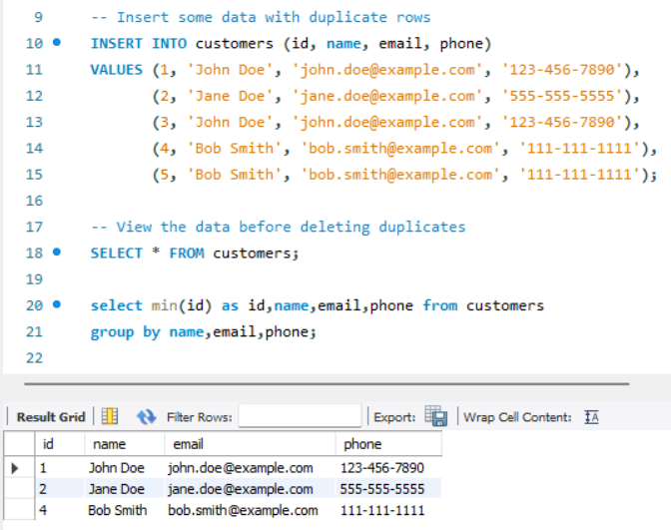

10. Show 5 records starting from 12th record.

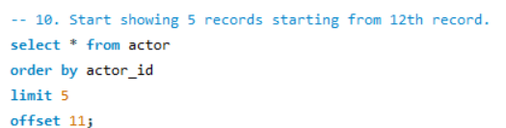

11. Select first and last (*) 5 records of a table in Ascending Order.

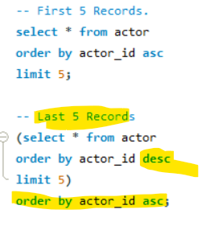

12. Write a SQL query to find out the first and last record of a table.

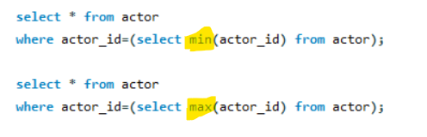

13. Write SQL query to find out the distinct records without using DISTINCT keyword.

* Here we need to use Group By.

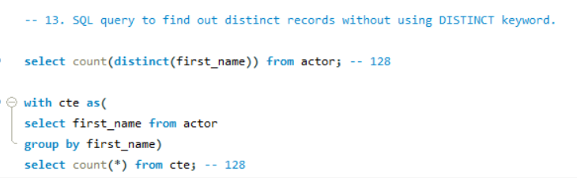

14. SQL query to find out the maximum salary of each group/department.

* SELECT
  + department,
  + MAX (salary) as Max_Salary
* FROM Employee
* GROUP BY department
* ORDER BY Max_Salary DESC;

15. SQL query to find out the department wise employee count in ascending order.

SELECT

department,

count (*) as employee count

FROM Employee

GROUP BY department

ORDER BY employee_count ASC;

16. How to change Data Type of a column.

1. ALTER TABLE <table name> MODIFY <column name> <new data type>

Mostly Asked Interview Questions

1. What do you mean by table and fields in the database?

Tables:

* A table is an organized collection of data stored in the form of rows and columns.
* It enables users to store and display records in a structured format.
* These tables are like worksheets in Spreadsheet applications.

Fields:

* Fields are nothing but columns that store a particular type of data in their cells. That means every field has its own defined datatype we can not store any kind of datatype in a field where a certain data type is already predefined.
* RECORDS: each row in a table is known as a record. A record consists of different types of values having different datatypes.

1. Difference between Unique Key, Primary Key, and Foreign Key.

Unique Key:

* Constraint Type: Unique Key
* Each cell for a particular column/field contains unique values.
* The unique Key column contains exactly one NULL value.
* One table may contain multiple Unique Key columns.
* The role of the Unique Key column is to ensure that each row and column in the table are unique.
* The Unique Key column can’t contain duplicate values.
* We can consider more than one column as a group and consider that group as a Unique Key column. Example: House Number+ Street Name+ State Name+ Country Name (Address Unique Key column)

Primary Key:

* Constraint Type: Primary Key
* When a particular column’s each cell in a table contains unique values and does not contain even one single NULL value then that column or field is known as a Primary Key column.
* A Primary Key column in a table helps to identify every record separately.
* One table can’t have more than one primary key column.
* The primary key column can’t even have one single NULL value in it.
* All the values in a primary key column are unique.
* Multiple columns of a particular table can be grouped together and form a primary key column just like a unique key column.
* The primary Key column plays an important role when we join multiple tables together.

Difference between PK and UK:

* UK column helps to uniquely identify records in a table when the PK column is not available.
* PK can’t contain NULL, but the UK can.
* One table can have only one PK, but it can have multiple UK.
* PK values can’t be changed or modified but UK column values can be changed/modified.

Foreign Key:

* FK columns are columns that store references of some Primary Key column present in some other table.
* FK columns play an important role when we join multiple tables together that is why FK columns are also known as “Referencing Key”.
* An FK column of a table is a PK column of another table.
* We need the FK column to build a relationship with the other tables where its referencing Primary Key column exists.

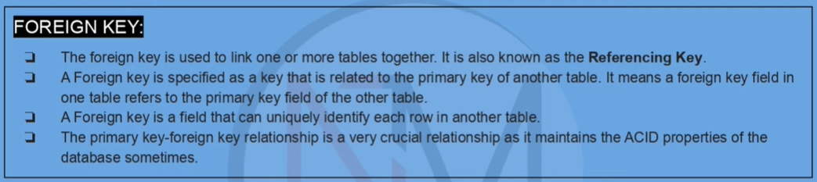

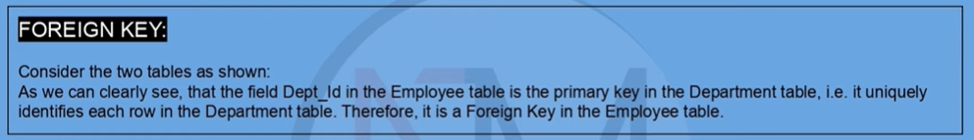

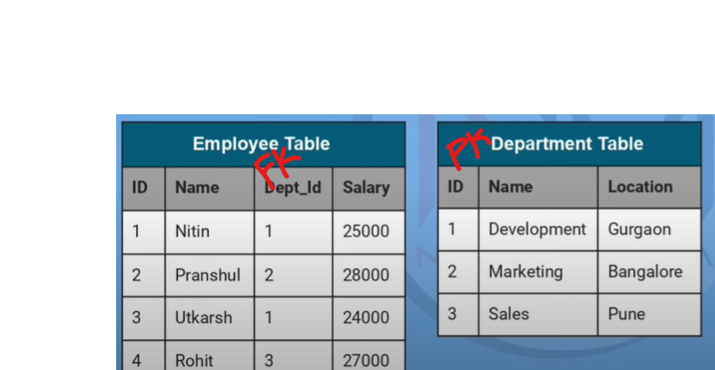

1. What is a SELECT statement in SQL? What are the common clauses used with it generally?

* The main purpose of the SELECT statement is to pull or fetch data from the database.
* The fetched data is stored and returned as a table called the result set.
* SELECT is a DML (Data Manipulation Language) command.
* FROM clause: Denotes the database/table/view from where the data is getting pulled with the help of the SELECT command.
* WHERE clause: Helps to filter records of a table based on certain criteria.
* ORDER BY clause: Helps to sort the record in Ascending (ASC) or Descending (DESC) order depending upon specific values or fields.
* GROUP BY clause: Whenever we want to aggregate our data, we use GROUP BY clause. It is used to group records with identical values and is generally used with aggregation functions in order to generate the summarized result.
* Having clause: It helps to apply filters on aggregated data. It is used in combination with Group By clause. It is different from the where clause as the WHERE clause can’t be applied with aggregated data.
* Limit: Helps to show the ‘n’ number of records from our database/table.
* Offset: Helps to skip a certain number of records.

1. What is JOIN? What are the different types of JOINs we have in SQL?

* When we want to pull or fetch data from more than one table generally then we use joins. Sometimes we use join on a particular table itself. SQL joins are majorly of 4 types.

1. Inner Join
2. Self-Join
3. Outer Join
4. Cross Join
5. Inner Join: This is like the intersection between two tables or sets where only common elements get selected.
6. Cross Join: This is like the Cartesian product of two tables. Suppose there are two tables. Table A and Table B. Each table has only one column. Table A has 5 records and Table B has 4 records. After doing the CROSS JOIN we will get a table where there will be 5*4=20 records.

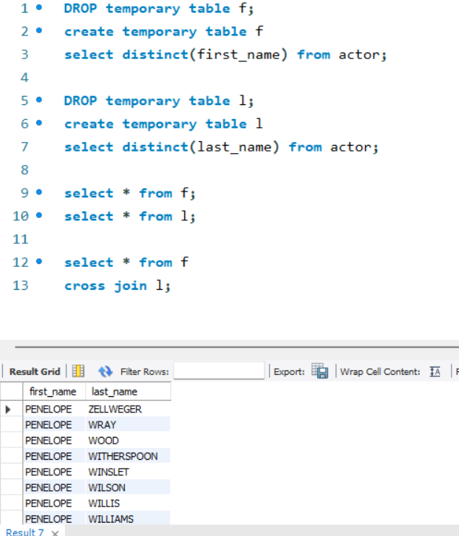

1. Self-Join: When we need to join a table with itself then we use the self-join technique. We
2. cannot use self-join in MySQL instead we have the Union function over there, but we can use self-join in PostgreSQL.

In MySQL, we can join a table with itself using different alias names. If we use the same name while joining, then we will get some errors.

1. Outer Join: There are basically three types of outer joins.
2. Left Outer Join
3. Right Outer Join
4. Full Outer Join
5. Left Outer Join: When we need to combine two tables and we need to pull all the records that are present in the left table (left table exclusive records + common records in both the table) then we use Left Join. In the merged table we get NULL values for the records where we do not find any match in the right table.
6. Right Outer Join: The same but opposite as Left Outer Join.
7. Full Outer Join: When we need all records of both the tables that we want to join then we use Full Outer Join. In this case, the merged table consists of common records + unique records of both the left and right table. Whenever we do not find any match between the left and right table we will get to see NULL values in the records of the merged table.
8. What is the difference between TRUNCATE, DELETE & DROP statement?

* Truncate, Delete and Drop commands used to manipulate data in a database, but they differ in their functionality and how they affect the data.

1. Truncate: This statement helps to delete all the records from a table without deleting the table itself. That means when we use TRUNCATE statement the data of the table get deleted permanently but the structure of the table remains intact or same. It is a faster operation than Delete. Once we execute the truncate command, we can’t retrieve the deleted data. Truncate is faster than Delete as Truncate does not store any cache data.

* Example: TRUNCATE TABLE table_name;

1. Delete: This statement is used to delete one or more than one record or rows from a table based on some certain condition. Delete statement stores the cache memory which is why we can retrieve the deleted records. As Delete operation stores the deleted information in the cache memory that is why Delete is slower than Truncate. Structure of the table remain unchanged but the manipulation of records happens.

* Example: DELETE FROM employee WHERE emp_id>10;

1. Drop: When we need to delete everything, the records inside the table along with the table’s structure then we use the Drop statement. The entire table gets deleted from the database and we can’t retrieve the table and the data contained by the table when we use the Drop statement. It deletes the table, its indexes, triggers, and constraints, making it the most drastic operation among these three. Once a table is dropped, it cannot be recovered, and all the data it contained is permanently lost.

* Example: Drop Table Employee;
* In summary, TRUNCATE is used to quickly delete all the data in a table, DELETE is used to remove specific rows from a table, and DROP is used to completely remove a table from a database.

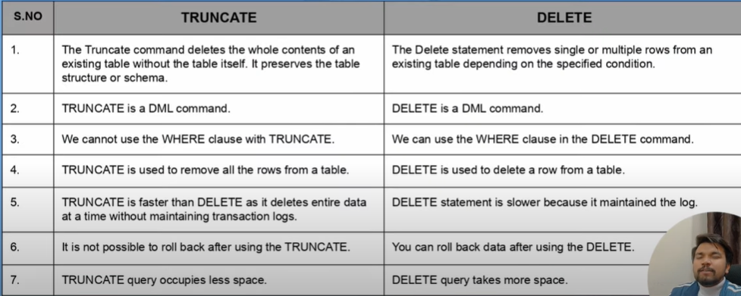

1. What is an “Alias” in SQL?

* An alias in SQL is an alternative name given to a table or column. It is used to make SQL queries more readable and easier to understand by providing a temporary name to a table or column in the query.

Aliases are created using the “AS” keyword followed by the alias name. The syntax for creating an alias for a table is as follows:

SELECT column_name(s) FROM table_name AS alias_name;

For example, the following query uses an alias for the table name "employees":

SELECT emp_id, emp_name, emp_salary FROM employees AS e;

In this query, "e" is an alias for the table name "employees", which makes the query more concise and easier to read.

Similarly, aliases can also be used for column names in the SELECT statement. The syntax for creating an alias for a column is as follows:

SELECT column_name AS alias_name FROM table_name;

For example, the following query uses an alias for the column name "emp_salary":

SELECT emp_id, emp_name, emp_salary AS salary FROM employees;

In this query, "salary" is an alias for the column name "emp_salary", which makes the output of the query more readable and understandable.

1. What are the Constraints in SQL?

Constraints in SQL are rules or restrictions that are enforced on the data belonging to certain columns of a table to ensure data integrity and consistency. Constraints are used to maintain the accuracy and validity of data in a table and to prevent the insertion of invalid or inconsistent data.

There are several types of constraints in SQL, including:

* Primary Key Constraint: It is a unique identifier that is used to identify each row in a table. The primary key constraint ensures that each row has a unique value for the primary key column and cannot be null.
* Foreign Key Constraint: It is used to create a relationship between two tables based on a common column. The foreign key constraint ensures that the values in the column of one table must exist in the column of another table.
* Unique Constraint: It ensures that the values in a column or a set of columns in a table are unique and cannot be repeated.
* Check Constraint: It is used to ensure that the data in a column satisfies a specific condition or set of conditions.
* Not Null Constraint: It ensures that a column cannot have a null value.

Constraints can be defined when creating a table or added to an existing table using the ALTER TABLE statement. By defining constraints, we can ensure that the data in a table is accurate, consistent, and valid. 

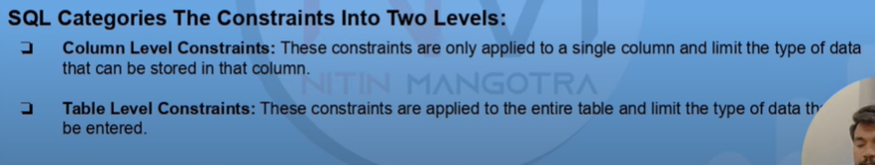

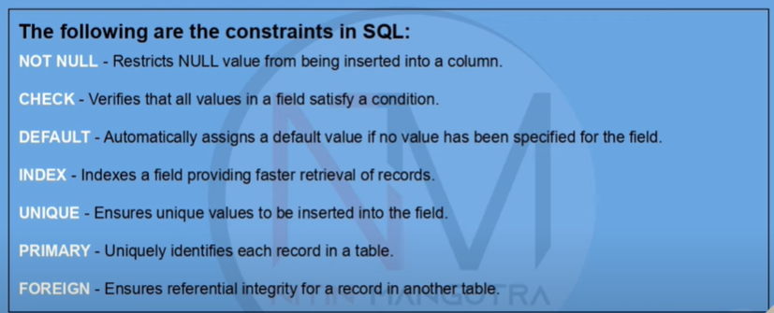

1. Difference between Where and Having clause in SQL?

In SQL, the WHERE clause and HAVING clause are used to filter data, but they differ in their functionality and usage.

WHERE Clause:

The WHERE clause is used to filter rows of a table/database based on a specific condition or set of conditions. It is used with the SELECT, UPDATE, and DELETE statements to restrict the result set based on one or more conditions. The WHERE clause filters rows based on columns that belong to the table, and it cannot be used with aggregate functions.

For example, the following SQL query retrieves all the customers whose age is greater than 30 from the "customers" table: SELECT * FROM customers WHERE age > 30;

HAVING Clause:

The HAVING clause is used to filter rows based on a specific condition or set of conditions, but it is used in conjunction with the GROUP BY clause to filter the result set based on the aggregate functions. The HAVING clause filters the result set based on columns that are generated by the aggregate functions, and it can only be used with aggregate functions.

For example, the following SQL query retrieves the total sales for each country and displays only those countries whose total sales are greater than 10000:

SELECT country, SUM(sales) AS total_sales

FROM orders

GROUP BY country

HAVING SUM(sales) > 10000;

In this query, the HAVING clause is used to filter the result set based on the total sales generated by the SUM() aggregate function.

In summary, the WHERE clause is used to filter rows based on a condition that belongs to a table, while the HAVING clause is used to filter the result set based on a condition that belongs to an aggregate function.

**We use HAVING clause to filter the aggregated data.

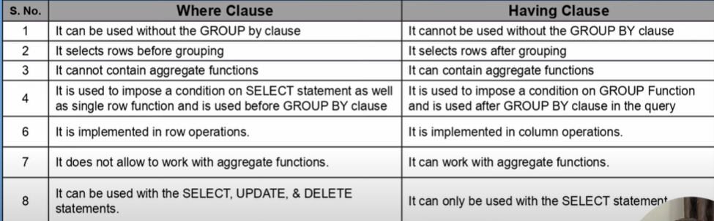

1. Difference between ‘IN’ and ‘Between’ operators in SQL.

The IN operator and the BETWEEN operator in SQL are used to filtering data based on certain criteria, but they differ in their functionality and usage.

IN Operator:

The IN operator is used to filter data based on a list of values. It is used in the WHERE clause of a SELECT, UPDATE, or DELETE statement to restrict the result set to a specified list of values. The IN operator checks whether a value is present in a specified list of values, and it returns true if the value matches any of the values in the list.

For example, the following SQL query retrieves all the customers whose country is either USA, UK, or Canada:

SELECT * FROM customers WHERE country IN ('USA', 'UK', 'Canada');

BETWEEN Operator:

The BETWEEN operator is used to filter data based on a range of values. It is used in the WHERE clause of a SELECT, UPDATE, or DELETE statement to restrict the result set to a specified range of values. The BETWEEN operator checks whether a value is between two specified values, and it returns true if the value falls within the range. Upper limit and Lower Limit are considered while filtering the values.

For example, the following SQL query retrieves all the orders whose order date is between January 1, 2022, and December 31, 2022:

SELECT * FROM orders WHERE order_date BETWEEN '2022-01-01' AND '2022-12-31';

In summary, the IN operator is used to filter data based on a list of values, while the BETWEEN operator is used to filter data based on a range of values.

1. 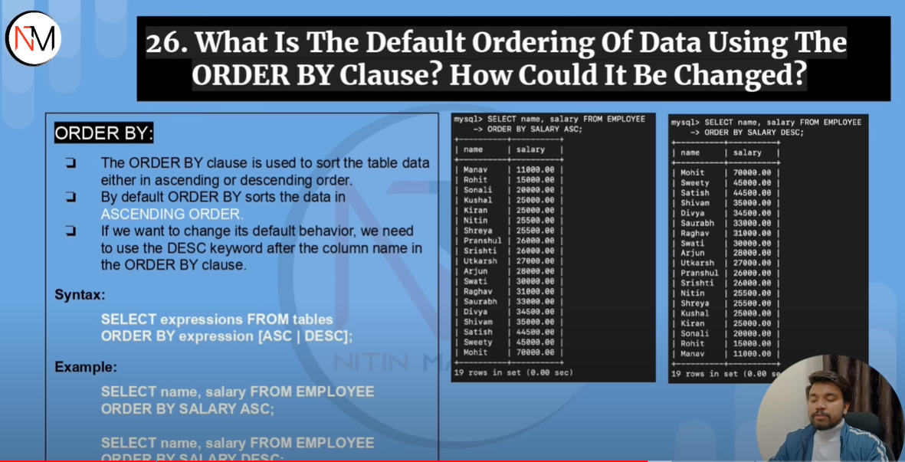

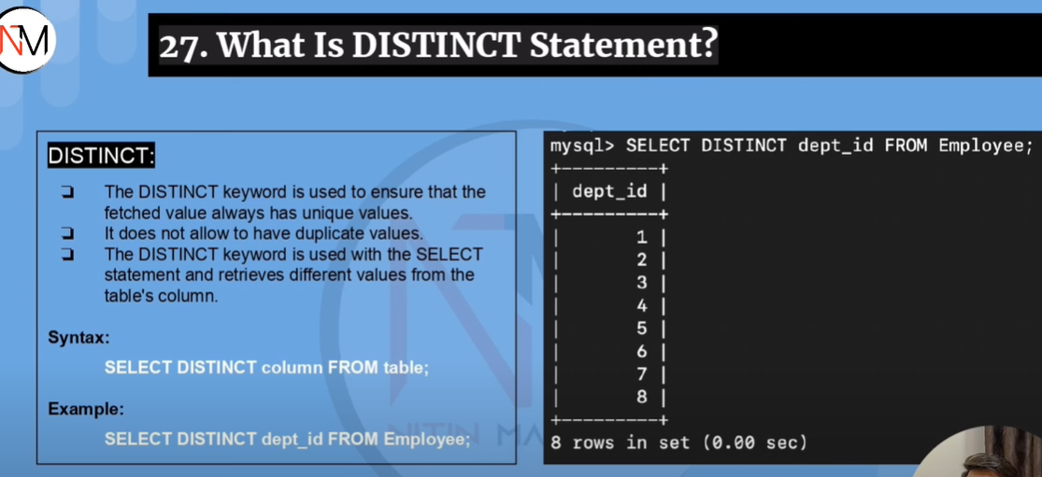



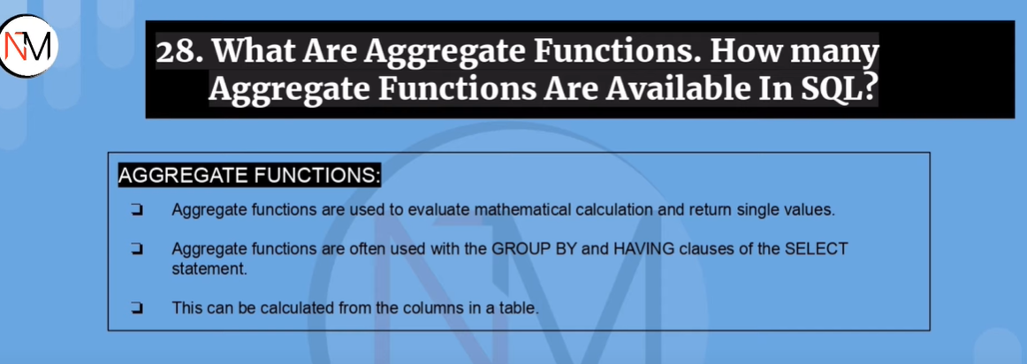

Aggregated functions in SQL are functions that perform a calculation on a set of values and return a single value. These functions are used to summarize or aggregate data in a table. Aggregated functions are often used with the GROUP BY clause to group the data by one or more columns and then calculate a summary or aggregate value for each group.

Some of the common aggregated functions in SQL are:

COUNT(): It is used to count the number of rows in a table or the number of non-null values in a column.

SUM(): It is used to calculate the sum of values in a column.

AVG(): It is used to calculate the average of values in a column.

MAX(): It is used to find the maximum value in a column.

MIN(): It is used to find the minimum value in a column.

For example, the following SQL query uses the SUM() function to calculate the total sales for each product category in the "sales" table:

SELECT category, SUM(sales) AS total_sales

FROM sales

GROUP BY category;

In this query, the GROUP BY clause is used to group the data by the "category" column, and the SUM() function is used to calculate the total sales for each category.

Aggregated functions are powerful tools in SQL that allow us to analyze and summarize large amounts of data quickly and efficiently. They can be used to generate reports, perform data analysis, and make informed decisions based on the data in a table.

1. What are the subsets of SQL?

SQL (Structured Query Language) is a standardized programming language used for managing and manipulating data in relational database management systems (RDBMS). There are several subsets of SQL that are used for specific purposes or within certain database management systems. Some of the common subsets of SQL are:

1. Data Definition Language (DDL): DDL is used to define the database schema, create tables, and specify constraints on the data. DDL statements include CREATE, ALTER, DROP, and TRUNCATE.
2. Data Manipulation Language (DML): DML is used to manipulate the data in the tables. DML statements include SELECT, INSERT, UPDATE, and DELETE.
3. Data Control Language (DCL): DCL is used to control access to the database and its objects. DCL statements include GRANT and REVOKE.
4. Transaction Control Language (TCL): TCL is used to control transactions in the database. TCL statements include COMMIT, ROLLBACK, and SAVEPOINT.
5. Data Query Language (DQL): DQL is used to retrieve data from one or more tables in the database. DQL statement is SELECT.
6. Procedural Language (PL/SQL): PL/SQL is an extension of SQL used for creating stored procedures, functions, and triggers in Oracle databases.
7. Structured Query Language/Data Stream Management System (SQL/DS): SQL/DS is a subset of SQL used for managing data streams in IBM's DB2 database management system.
8. Transact-SQL (T-SQL): T-SQL is an extension of SQL used for programming and managing Microsoft SQL Server databases.

These subsets of SQL have their own syntax and functionality, but they share a common foundation of SQL. Understanding these subsets is important for working with specific database management systems and for performing specific tasks related to data management and manipulation.

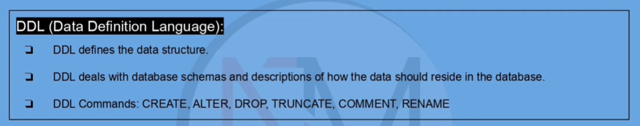

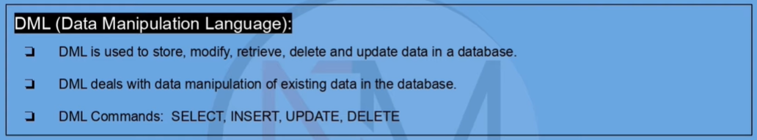

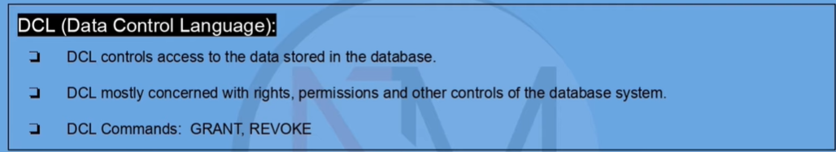

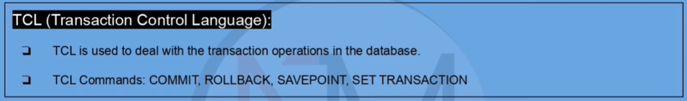

1. What are the types of relationships in SQL?

In SQL, there are three types of relationships that can exist between tables in a relational database: one-to-one, one-to-many, and many-to-many.

1. One-to-One Relationship:

In a one-to-one relationship, one record in a table is related to one and only one record in another table. This type of relationship is not very common in databases, but it can be used to split a table into two to improve performance or to store optional data. In a one-to-one relationship, the primary key of one table is used as a foreign key in the other table.

1. One-to-Many Relationship:

In a one-to-many relationship, one record in a table is related to one or more records in another table. This is the most common type of relationship in databases. In a one-to-many relationship, the primary key of the "one" table is used as a foreign key in the "many" table. For example, a customer can have multiple orders, but each order is related to only one customer.

1. Many-to-Many Relationship:

In a many-to-many relationship, multiple records in one table are related to multiple records in another table. This type of relationship requires a third table, called a junction table or a bridge table, to map the relationships between the two tables. In a many-to-many relationship, the primary keys of both tables are used as foreign keys in the junction table. For example, a student can enroll in multiple courses, and each course can have multiple students.

Understanding the types of relationships in SQL is essential for designing a well-structured database schema that efficiently stores and manages data.

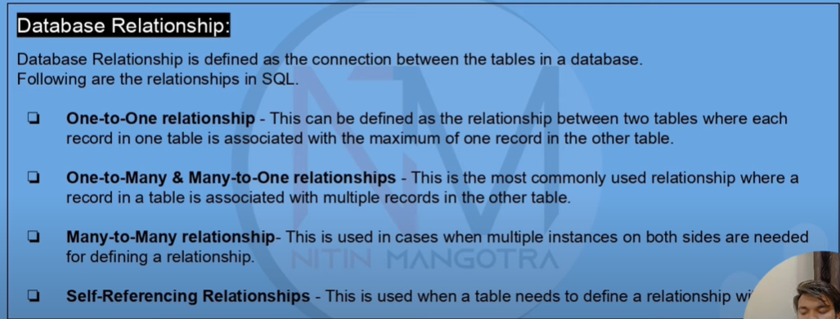

1. What is RDBMS and how it is different from DBMS?

RDBMS stands for Relational Database Management System, while DBMS stands for Database Management System. The main difference between RDBMS and DBMS is that RDBMS stores data in the form of tables or relations, while DBMS stores data in any format, including hierarchical, network, and object-oriented.

An RDBMS is a type of DBMS that stores and manages data in a relational database. A relational database is a collection of tables that are related to each other based on a common field or key. RDBMS uses Structured Query Language (SQL) to manage and manipulate data in the tables. Some popular RDBMS include Oracle, MySQL, Microsoft SQL Server, and PostgreSQL.

RDBMS provides several advantages over DBMS, including:

Data consistency: RDBMS enforces data integrity rules to ensure that data is consistent across tables and transactions.

Scalability: RDBMS can handle large amounts of data and support multiple users simultaneously.

Flexibility: RDBMS can support a variety of data types and can easily integrate with other applications and systems.

Security: RDBMS provides robust security features to protect data from unauthorized access and ensure data privacy.

Performance: RDBMS is optimized for performance and can quickly retrieve and manipulate data.

In summary, RDBMS is a type of DBMS that stores data in tables or relations and uses SQL to manage and manipulate data. RDBMS provides several advantages over DBMS, including data consistency, scalability, flexibility, security, and performance.

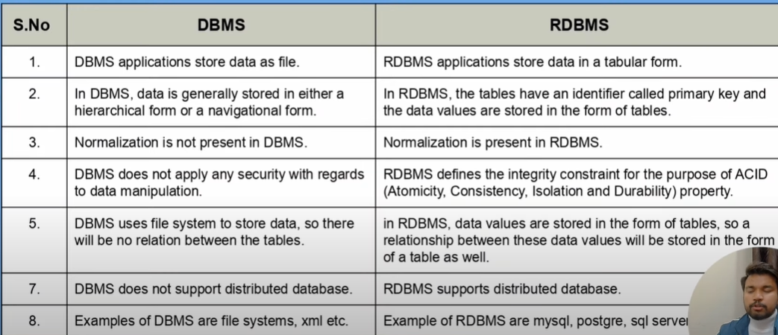

Commonly Asked Questions:

1. What is a Query in SQL?

In SQL, a query is a request for data or information from a database. It is a statement or instruction that is used to retrieve, filter, and manipulate data stored in tables within a database. SQL queries are written in a specific manner (syntax) that is used to interact with the database.

A SQL query typically consists of three main components:

SELECT statement: This is used to specify the columns that you want to retrieve from the table.

FROM clause: This specifies the table from which you want to retrieve data.

WHERE clause: This is used to filter the data based on certain conditions.

For example, the following SQL query retrieves all the records from the "Customers" table where the "Country" is "USA":

SELECT * FROM Customers

WHERE Country = 'USA';

SQL queries can be simple or complex, depending on the requirements. You can use various functions, operators, and clauses in SQL to write complex queries that can perform tasks such as data aggregation, grouping, sorting, and joining multiple tables.

SQL queries are an essential part of working with databases, and they are used extensively in data analysis, reporting, and business intelligence.

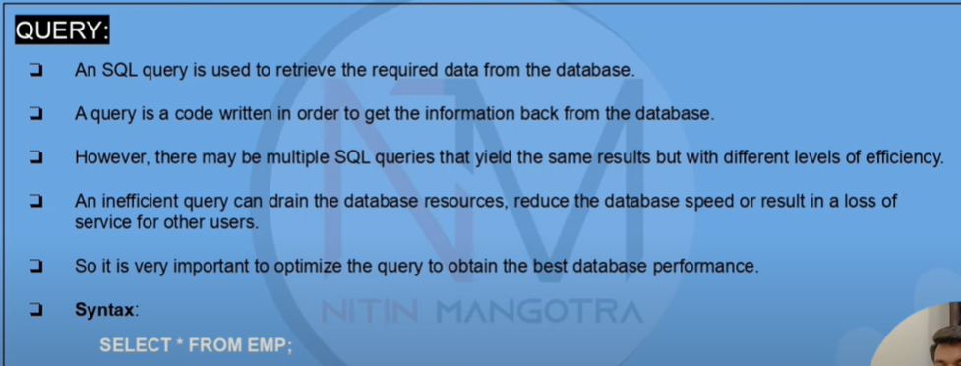

1. What is a Sub-query and what are its different types?

A subquery in SQL is a query that is embedded within another query. It is a query that is written inside another query to retrieve data needed to complete the main query. A subquery can be used in various parts of a SQL statement, including the WHERE clause, HAVING clause, and FROM clause.

Types of Subqueries in SQL:

Single-row Subquery:

A single-row subquery is a subquery that returns only one row of data. It is used in a WHERE clause to compare a single value with a set of values returned by the subquery.

Example:

SELECT product_name, unit_price

FROM products

WHERE unit_price = (SELECT MAX(unit_price) FROM products);

Multiple-row Subquery:

A multiple-row subquery is a subquery that returns more than one row of data. It is used in a WHERE clause to compare a set of values with another set of values returned by the subquery.

Example:

SELECT order_id, customer_id, order_date

FROM orders

WHERE customer_id IN (SELECT customer_id FROM customers WHERE country = 'USA');

Correlated Subquery:

A correlated subquery is a subquery that depends on the outer query for its values. It is used in a WHERE clause to filter the results based on the values of the outer query.

Example:

SELECT product_name, unit_price, category_id

FROM products p

WHERE unit_price > (SELECT AVG(unit_price) FROM products WHERE category_id = p.category_id);

Nested Subquery:

A nested subquery is a subquery that is embedded within another subquery. It is used to retrieve data from multiple tables and join them together.

Example:

SELECT customer_name, city, country

FROM customers

WHERE country IN (SELECT country FROM orders WHERE customer_id IN (SELECT customer_id FROM order_details WHERE product_id IN (SELECT product_id FROM products WHERE category_id = 1)));

In summary, a subquery is a query that is embedded within another query in SQL. There are different types of subqueries, including single-row, multiple-row, correlated, and nested subqueries, each with its own purpose and syntax.

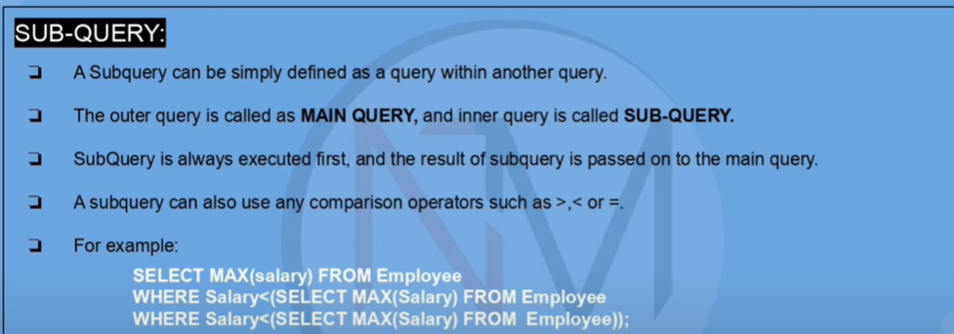

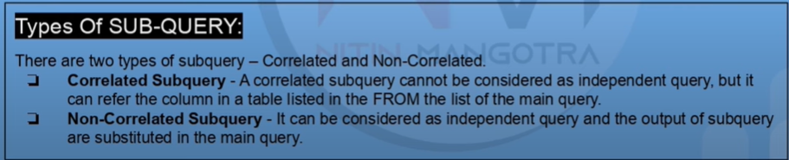



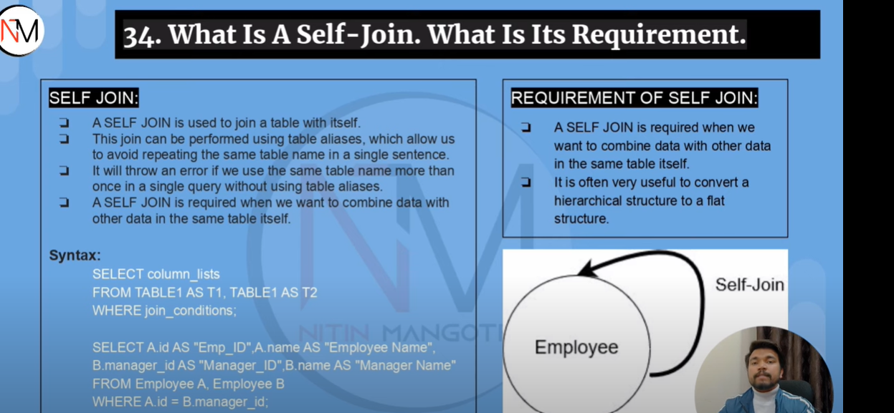



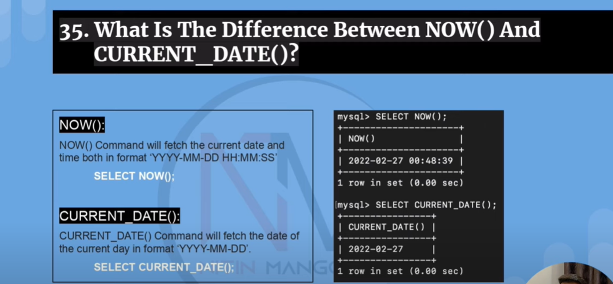



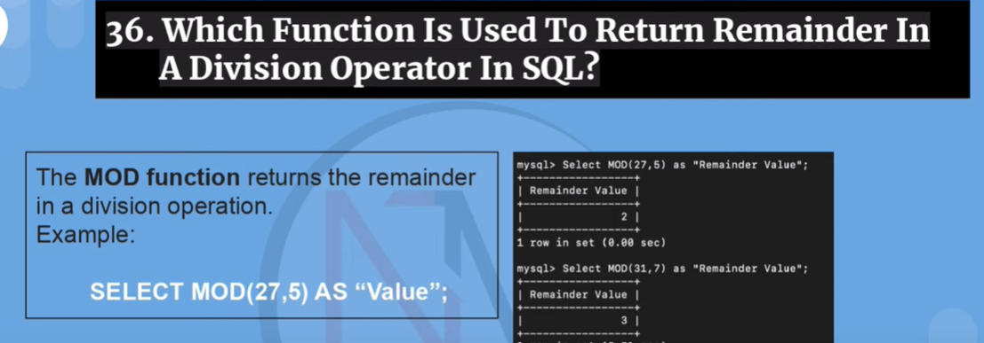



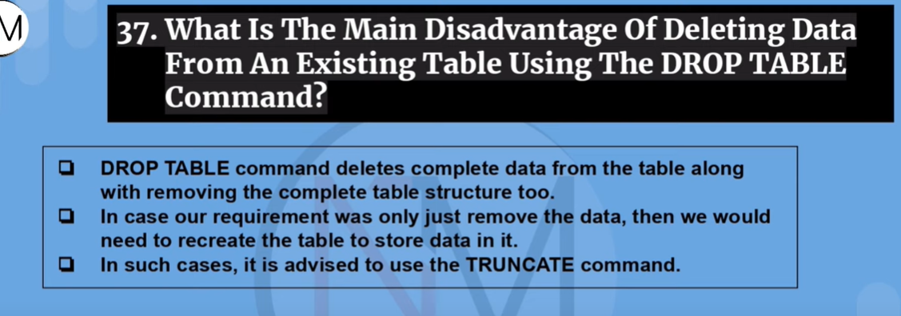

1. Difference between CHAR and VARCHAR?

In SQL, both CHAR and VARCHAR are used to store character string data. However, there are some key differences between the two data types.

CHAR:

CHAR is a fixed-length data type. It requires a specified length when defining the column, and it always stores the same length of data in the column, regardless of the actual length of the value being stored.

CHAR columns are padded with spaces at the end of the value to fill the entire length of the column.

The maximum length of a CHAR column is 8,000 characters.

Example:

CREATE TABLE employees (

emp_id INT,

emp_name CHAR(20),

emp_city CHAR(15)

);

In the above example, the emp_name column will always store 20 characters, and the emp_city column will always store 15 characters, even if the actual values stored in the columns are shorter than that.

VARCHAR:

VARCHAR is a variable-length data type. It requires a specified maximum length when defining the column, but it only stores the actual length of the data being stored in the column, without any padding.

VARCHAR columns do not use any padding with spaces, which can save storage space compared to CHAR columns.

The maximum length of a VARCHAR column is also 8,000 characters.

Example:

CREATE TABLE products (

product_id INT,

product_name VARCHAR(50),

product_description VARCHAR(200)

);

In the above example, the product_name column will store up to 50 characters, but if the actual length of the value is less than 50, it will only store the actual length.

In summary, the main difference between CHAR and VARCHAR is that CHAR is a fixed-length data type, while VARCHAR is a variable-length data type. Choosing between them depends on the nature of the data being stored and the requirements of the database design.

My Understanding: Char (10) will always take the storage space required for 10 characters even though the length of the string is less than 10 characters. Whereas Varchar (10) will maximum take 10 characters. If we want to store any string whose size is less than 10 characters, then memory space will be captured required to store that string only. It will not capture or occupy the memory space required for 10 characters.

Char Datatype is used when we know the string length is going to be fixed and not be variable length. Like Pin code, phone number, short name of Month or week. These will always take fixed number of spaces throughout the data life cycle. Unlike any name which will be of variable length.



Scalar functions in SQL are functions that take one or more arguments as input and return a single value as output. These functions operate on individual values and do not require any aggregation. Scalar functions can be used in SELECT, WHERE, and ORDER BY clauses of a SQL statement.

Concat(),Length(),Upper(),Lower(),Round(),Mod(),Now(),Date() etc.



1. What is a Database?

A database is a collection of organized data that is stored and accessed electronically. It is designed to efficiently store, retrieve, and manage large amounts of data. A database can be thought of as an electronic filing system, where data is organized and stored in tables, and these tables are related to each other to provide a complete picture of the data.

Databases are used in a wide range of applications, from small personal databases to large enterprise-level systems. They are commonly used in business, education, healthcare, and other industries to manage and analyze data. Databases are essential for storing and managing data that can be accessed and used by multiple users or applications simultaneously.

Some of the key features of a database include:

Data Integrity: Databases provide a mechanism for enforcing rules to ensure the integrity of data, such as data validation, constraints, and referential integrity.

Security: Databases provide a way to secure data through authentication, authorization, and encryption.

Scalability: Databases can be designed to scale horizontally or vertically, to meet the needs of growing data volumes and user demands.

Data Consistency: Databases provide a way to ensure that data is consistent and accurate across multiple tables and applications.

Overall, a database is a powerful tool for storing and managing data, and it plays a crucial role in many aspects of modern society.

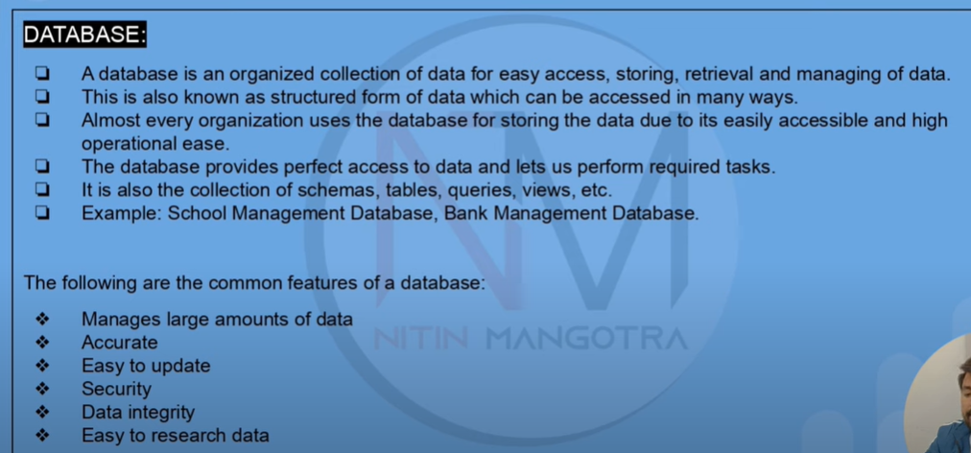

1. What is SQL? What are the differences between NoSQL and SQL databases?

SQL (Structured Query Language) is a programming language used for managing and manipulating data in relational databases. It provides a standardized way to interact with data in relational databases, which are based on the relational model of data.

NOSQL (Not Only SQL) databases, on the other hand, are non-relational databases that do not use SQL as their primary query language. Instead, they use other query languages or APIs to interact with data. NOSQL databases are designed to handle large amounts of unstructured or semi-structured data and are often used in applications that require high scalability and performance.

Here are some of the key differences between SQL and NOSQL databases:

Data Model: SQL databases are based on the relational model of data, which organizes data into tables with predefined relationships between them. NOSQL databases, on the other hand, use various data models such as key-value, document, graph, or column-family.

Scalability: SQL databases are vertically scalable, which means that they can handle larger amounts of data by increasing the resources of a single machine. NOSQL databases, on the other hand, are horizontally scalable, which means that they can handle larger amounts of data by adding more machines to a cluster.

Query Language: SQL databases use SQL as their primary query language, which provides a standardized way to interact with data. NOSQL databases use various query languages or APIs, which can vary depending on the specific database system.

Data Consistency: SQL databases provide strong consistency, which ensures that all data in the database is in a consistent state. NOSQL databases often sacrifice consistency for scalability and performance, which means that they may allow for eventual consistency or other weaker forms of consistency.

Overall, both SQL and NOSQL databases have their own strengths and weaknesses, and the choice of database system depends on the specific requirements of the application. SQL databases are well-suited for applications that require complex queries and strong consistency, while NOSQL databases are better suited for applications that require high scalability and performance with flexible data models.

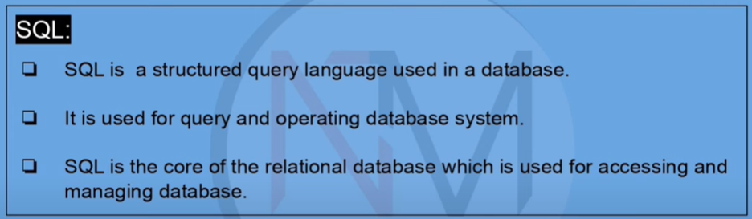

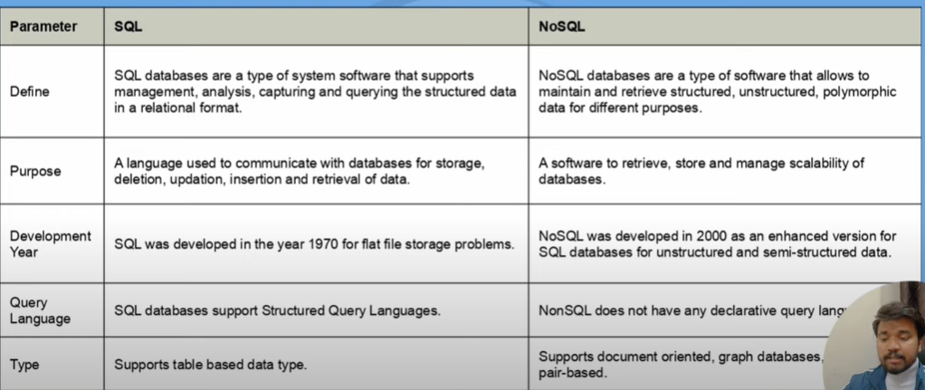



SQL (Structured Query Language) is a programming language used for managing and manipulating data in relational databases. It is a standardized language used across various database management systems (DBMS) such as MySQL, Oracle, Microsoft SQL Server, and PostgreSQL.

MySQL, on the other hand, is a popular open-source relational database management system that uses SQL as its primary query language. MySQL is developed, distributed and supported by Oracle Corporation.

Here are some key differences between SQL and MySQL:

SQL is a language, while MySQL is a relational database management system that uses SQL as its primary query language.

SQL is a standardized language used across different relational database systems, while MySQL is specific to the MySQL database management system.

SQL can be used to query, manipulate, and manage data in any relational database, while MySQL is a specific implementation of a relational database that provides additional features such as user management, security, and administration.

SQL can be used with various programming languages and frameworks, while MySQL is often used with web applications and popular web development languages such as PHP.

Overall, SQL is a language used for managing and manipulating data in relational databases, while MySQL is a specific implementation of a relational database that uses SQL as its primary query language. While they are related, they are not the same thing, and it is important to understand the differences between them when working with databases.

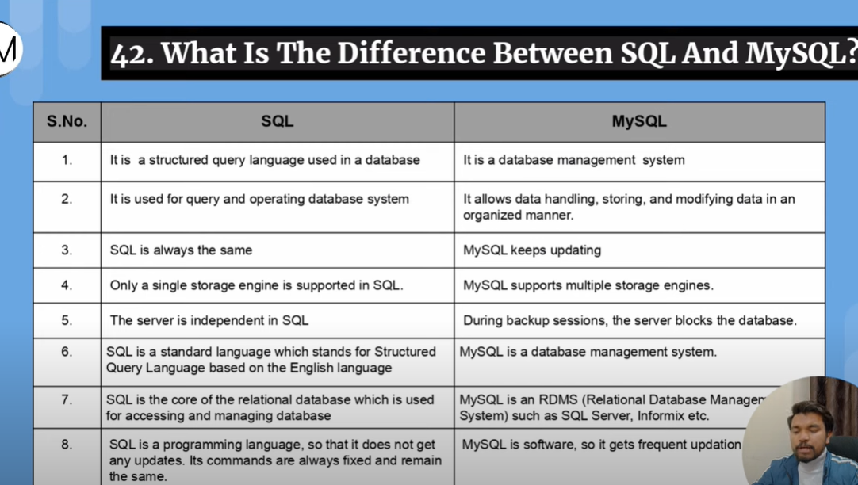

1. What do you mean by DBMS? and what are its different types?

DBMS stands for Database Management System, which is a software system that provides a way to store, organize, and manage data in a database. A DBMS provides a set of tools and services that enable users to interact with data in the database, including creating, modifying, querying, and deleting data.

There are several types of DBMS, including:

Relational DBMS: This is the most common type of DBMS, which uses the relational model of data to organize data in tables with predefined relationships between them. Examples of relational DBMS include MySQL, Oracle, Microsoft SQL Server, and PostgreSQL.

Object-oriented DBMS: This type of DBMS uses an object-oriented model of data, where data is organized into objects with attributes and methods. Examples of object-oriented DBMS include ObjectDB and db4o.

Hierarchical DBMS: This type of DBMS organizes data in a hierarchical structure, where each record has a parent and child record. Examples of hierarchical DBMS include IBM's Information Management System (IMS) and CA-IDMS.

Network DBMS: This type of DBMS uses a network model of data, where each record can have multiple parent and child records. Examples of network DBMS include Integrated Data Store (IDS) and IDMS/Network.

NoSQL DBMS: This type of DBMS uses non-relational data models such as key-value, document, graph, or column-family to organize and manage data. Examples of NoSQL DBMS include MongoDB, Cassandra, and Couchbase.

Overall, the choice of DBMS depends on the specific requirements of the application, including the type of data being stored, the volume of data, the performance requirements, and the need for scalability and flexibility.

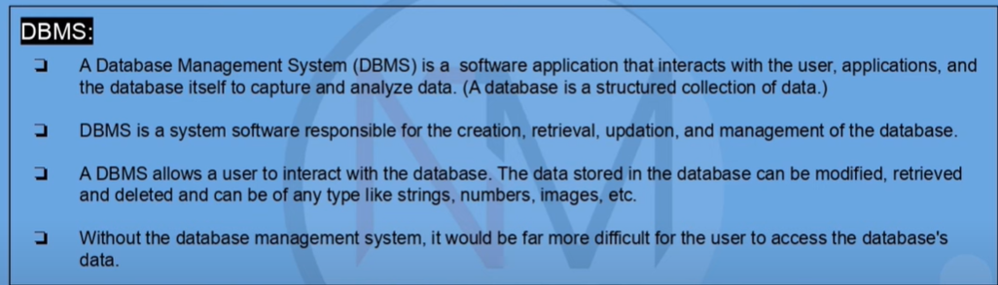

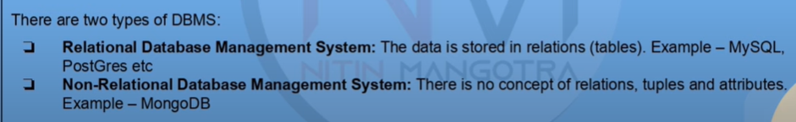

Advanced Questions:

1.

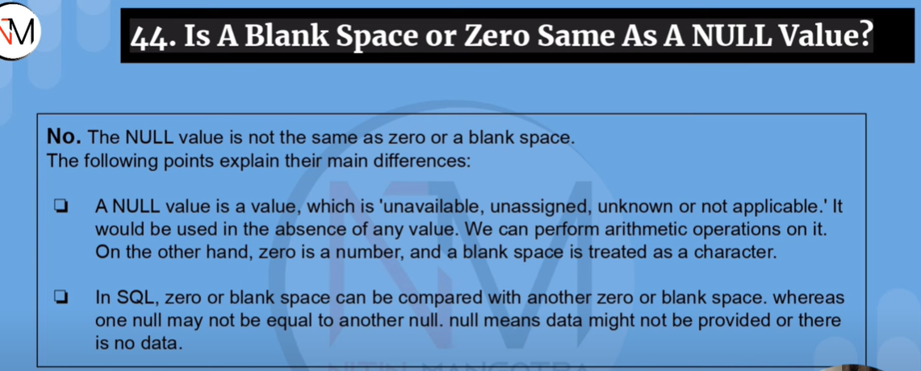

Suppose, we have table movie review table and this table has information of how each customers rated the movie. Let some customers have not given any rating for the movie, in those places we will put NULL but can’t put zero as zero will be considered as a rating.

2. What is Union, Union All, Minus and Intersect in SQL?

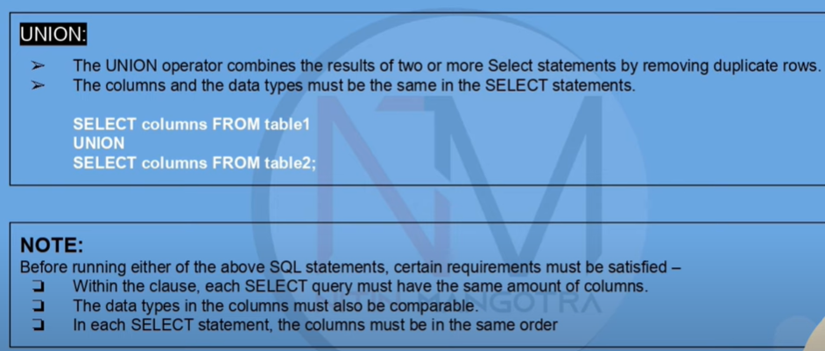

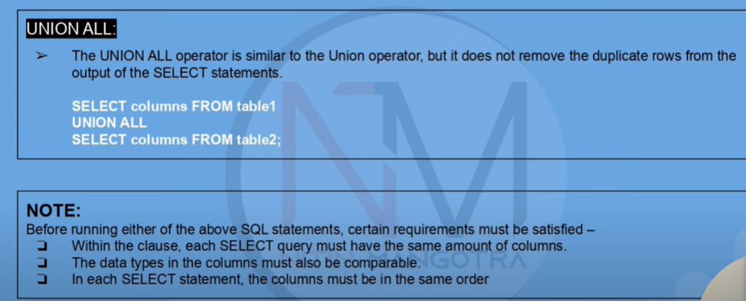

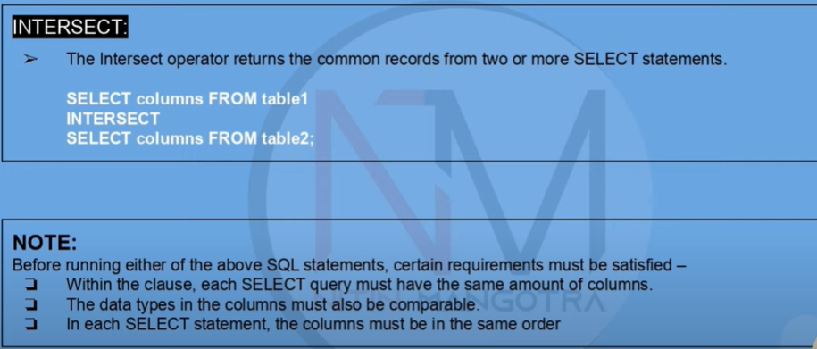

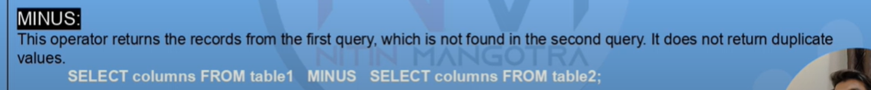

**Union, Union All, Minus, and Intersect are set operators in SQL that allow us to combine or compare the results of two or more SELECT statements.**

1. **Union: The Union operator combines the results of two SELECT statements into a single result set by removing duplicate rows. The syntax for using the Union operator is:**

**SELECT column1, column2**

**FROM table1**

**UNION**

**SELECT column1, column2**

**FROM table2;**

1. **Union All: The Union All operator is similar to Union, but it does not remove duplicate rows from the result set. The syntax for using the Union All operator is:**

**SELECT column1, column2**

**FROM table1**

**UNION ALL**

**SELECT column1, column2**

**FROM table2;**

1. **Except (Minus): The Except (or Minus) operator returns all the distinct rows from the first SELECT statement that are not in the second SELECT statement. The syntax for using the Except (or Minus) operator is:**

**SELECT column1, column2**

**FROM table1**

**EXCEPT**

**SELECT column1, column2**

**FROM table2;**

1. **Intersect: The Intersect operator returns only the distinct rows that are common to both SELECT statements. The syntax for using the Intersect operator is:**

**SELECT column1, column2**

**FROM table1**

**INTERSECT**

**SELECT column1, column2**

**FROM table2;**

**Note that the number and data types of columns in each SELECT statement must match for the set operators to work correctly. Also, the results of set operations are always returned in ascending order and the column names of the result set are taken from the first SELECT statement.**

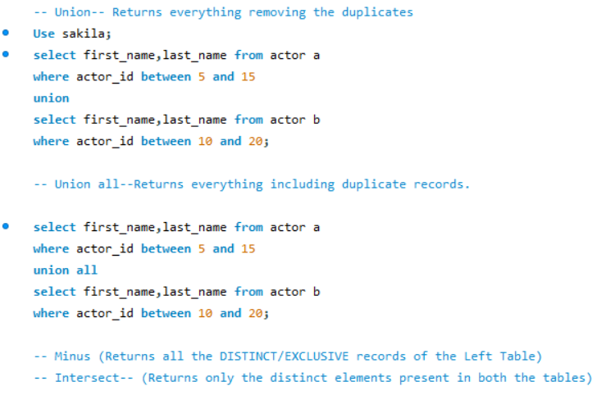

**3.** **What are the ACID properties in a Data Base?**

* **ACID is an acronym for the four essential properties of a transaction in a database system:**

1. **Atomicity: This property ensures that a transaction is treated as a single, indivisible unit of work that must be either completed in its entirety or not at all. If any part of a transaction fails, the entire transaction is rolled back and any changes made during the transaction are undone.**

* **We can compare it with UPI payment. Suppose, I am making a payment and somehow there is some issue in the payment process then the transaction gets canceled and money does not get deducted from my account or even if it gets deducted it comes back after a certain time.**

1. **Consistency: This property ensures that a transaction takes the database from one consistent state to another. A consistent state is one that meets all the database constraints, such as data type, primary key, and foreign key constraints.**
2. **Isolation: This property ensures that a transaction is executed in isolation from other transactions. Each transaction should feel like it is the only one operating on the database. This means that transactions that are executed concurrently should not interfere with each other, and the results of a transaction should not be visible to other transactions until the transaction has been committed.**

* **We can think of this in a way like when we process any payment it is not like we only process the payment at that time, there would be n number of users who also process the payment at the same time. So, this Isolation property helps to keep each transaction unique.**

1. **Durability: This property ensures that once a transaction is committed, its effects are permanent and will survive any subsequent system failures, including power outages, crashes, or network errors. The changes made during the transaction are stored on durable media, such as a hard disk or solid-state drive, so they can be recovered in case of a failure.**

* **We can think of this in a way like when we send money to our friends and the money is credited to friend’s account there is no chance that will return automatically.**

**Together, these properties ensure that transactions in a database are reliable, consistent, and durable, and that data remains in a consistent state even in the face of errors or concurrent access by multiple users or applications.**

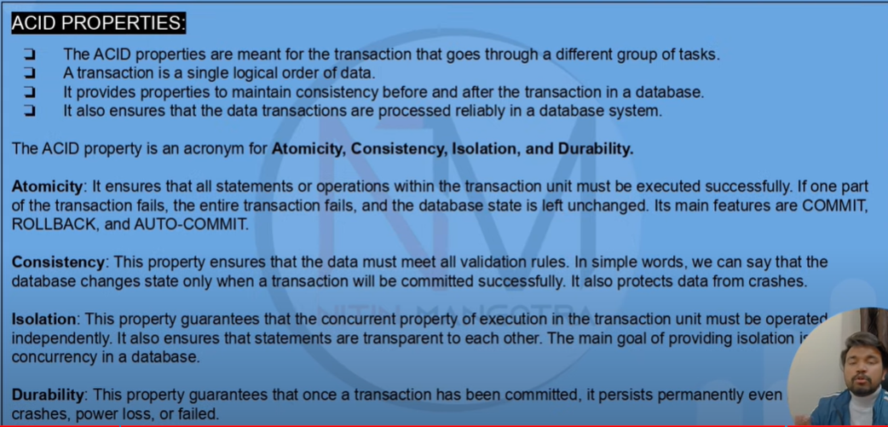



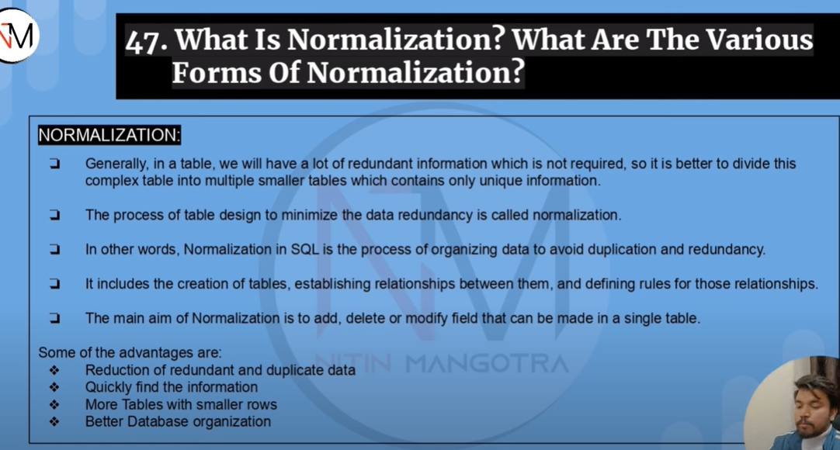

**First Normal Form (1NF): This is the most basic level of normalization. It requires that each table column should contain only atomic values and that each row in a table should be unique.**

**Second Normal Form (2NF): This level of normalization requires that each non-key column in a table must be dependent on the entire primary key, and not just a part of it.**

**Third Normal Form (3NF): This level of normalization requires that each non-key column in a table must be dependent only on the primary key and not on any other non-key columns.**

**Boyce-Codd Normal Form (BCNF): This level of normalization is similar to 3NF but requires that all functional dependencies be fully satisfied, even those that are not determined by the primary key.**

**Fourth Normal Form (4NF): This level of normalization requires that a table should not have any multi-valued dependencies.**

**Fifth Normal Form (5NF): This level of normalization requires that a table should not have any join dependencies.**

**Each level of normalization builds on the previous level and requires that the database tables meet more stringent requirements. By normalizing data, we can reduce data redundancy and improve database performance, while ensuring data consistency and accuracy.**

1. **Disadvantages of not performing normalization.**

**The following are some of the disadvantages of not performing normalization in a database:**

* **Data Redundancy: Redundancy occurs when the same data is stored in multiple places in the database. This can lead to inconsistencies in the data, as well as wasted storage space.**
* **Data Inconsistency: Inconsistencies can occur when data is updated in one place but not in another. This can lead to inaccuracies and errors in the data.**
* **Poor Performance: As the size of the database increases, the performance of the system can degrade. Unnormalized tables can require more disk space, slower query performance, and slower transaction processing.**
* **Limited Flexibility: Unnormalized tables can be inflexible and difficult to modify. Adding or removing columns can require extensive changes to the table structure and data.**
* **Security Risks: Poorly designed databases can be more vulnerable to security threats such as SQL injection attacks, where malicious code can be injected into SQL statements to access or manipulate data in unauthorized ways.**
* **Difficulty in Querying Data: Unnormalized tables can be difficult to query and analyze, as data may be scattered across multiple tables, and it may be difficult to join tables to retrieve relevant data.**

**In summary, not performing normalization can lead to inefficiencies, inaccuracies, security risks, and difficulties in managing and querying data in a database.**

1. **What is denormalization?**

**Denormalization is the process of intentionally introducing redundancy into a database to improve query performance. It involves selectively adding redundant data to one or more tables to avoid the overhead of joining tables together to retrieve data. The goal of denormalization is to improve query performance by reducing the number of joins required to retrieve data.**

**Denormalization is typically used in situations where query performance is critical, and the cost of maintaining the redundancy is outweighed by the performance benefits. However, denormalization can also lead to data inconsistencies if not managed properly. When data is denormalized, care must be taken to ensure that redundant data is updated consistently with the source data.**

**There are several techniques for denormalizing data, such as creating summary tables or adding additional columns to a table. Denormalization can be done at different levels of the database design, such as the logical or physical level, depending on the specific needs of the application.**

**While denormalization can improve query performance in certain situations, it should be used with caution and only after careful analysis of the specific performance requirements and tradeoffs involved.**

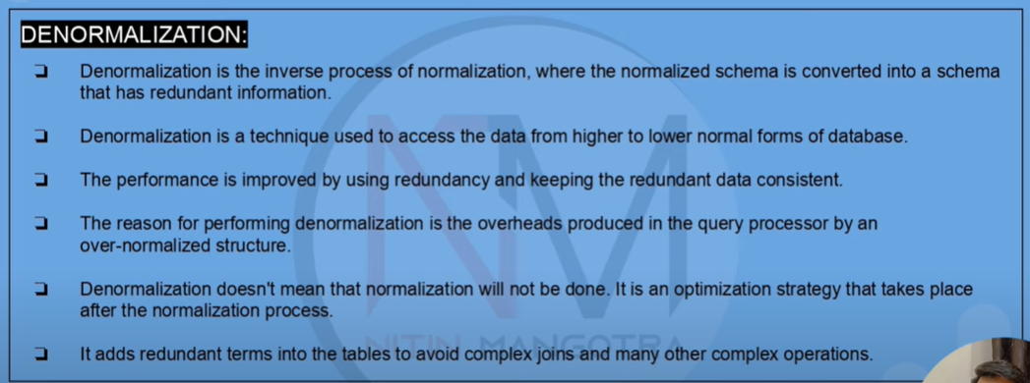



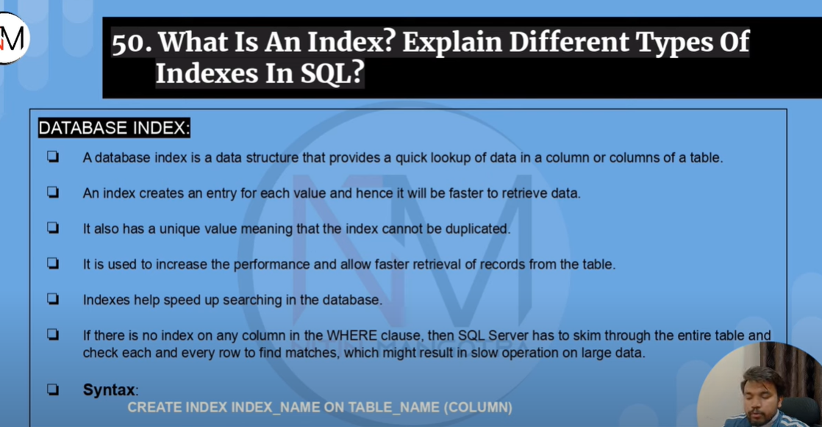

**8.**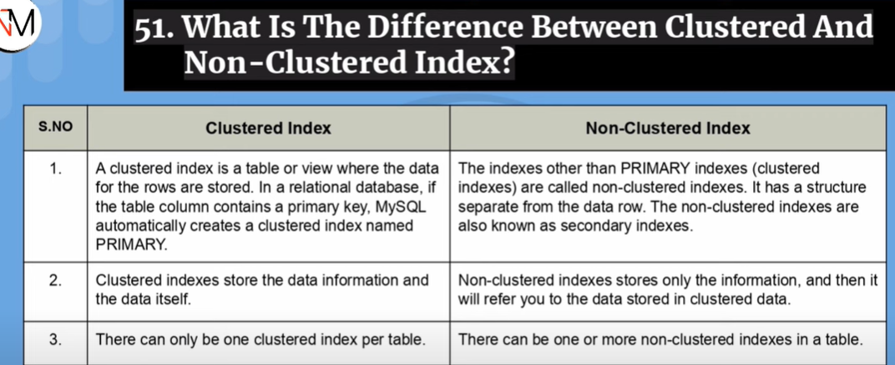

9. What is View in Database?

In a database, a view is a virtual table that is based on the result set of a SQL statement. It is a stored query that can be accessed like a regular table, but it does not actually store data itself. Instead, a view retrieves data from one or more tables in the database and presents it in a customized way.

Views can be used to simplify queries and improve database performance by reducing the number of tables that need to be joined together. They can also be used to enforce security and access controls by limiting the data that users can see and modify. Views can be created by database administrators or users with appropriate permissions.

Views can be thought of as virtual tables that provide a way to look at data from different angles or perspectives. They can be used to hide complexity and simplify the querying process. Views can also be used to create reports or subsets of data that are tailored to specific user requirements.

In summary, a view in a database is a virtual table that is based on the result set of a SQL statement, which provides a simplified and customized way of accessing data from one or more tables in the database.

* We can think it of like a set of queries which can be stored in the database and whenever we want to get the same out put we can only run that query and it generates the output. It helps us not to write big big SQL queries repeatedly. It reduces the query writing complexity and reduces time to retrive the desired data.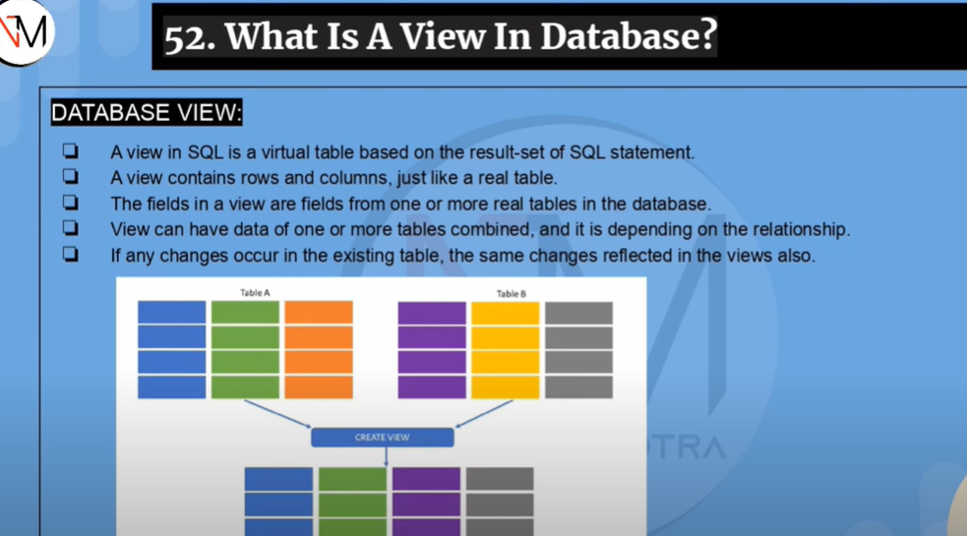

10. What is the difference between OLAP and OLTP?

OLAP and OLTP are two different types of database systems, each designed to serve specific business needs. OLAP stands for Online Analytical Processing, while OLTP stands for Online Transaction Processing.

OLTP databases are designed to handle transactions in real-time. They are optimized for fast and efficient processing of individual transactions, such as placing an order or making a payment. OLTP databases typically have a normalized schema, which means that data is stored in a highly structured manner with many tables and relationships. OLTP databases are used for day-to-day transactional operations in businesses, such as order processing, inventory management, and customer relationship management.

On the other hand, OLAP databases are designed to support complex analysis and reporting. They are optimized for fast querying and aggregation of large volumes of data, typically historical data. OLAP databases often have a denormalized schema, which means that data is stored in fewer tables with more redundancy. This simplifies queries and allows for faster data retrieval. OLAP databases are used for business intelligence and decision-making purposes, such as sales analysis, financial reporting, and trend analysis.

In summary, OLTP databases are designed for transaction processing in real-time, with a highly normalized schema, while OLAP databases are designed for complex analysis and reporting, with a denormalized schema optimized for fast querying and aggregation of large volumes of data.

